**Sales Q&A**

Solving Problems Strategies

Contents

1. [**General**] What are functions of Business Development Department, Operation Department, Finance Department, Production Department..................3
2. [**Registration Form**] What do i do when i received registration form?...........................................................................................................................................................4-5
3. [**Payment**] My client has registered, and received invoice but 3 working days already passed, I haven’t heard about solid payment proof from their Finance..............................................................................................................................................................................................................................................................................................6
4. [**Payment**] My client has registered, but registration is less than 03 weeks prior to event date.............................................................................................................6

**1. What are functions of Business Development Department, Operation Department, Finance Department, Production Department?**

**Sales Department:**

* Pricing: All inquiries related to discount
* Sales and Pitching strategies
* Closing
* Cancellation

**Production Department**

* Product specification
* Product specification selling points

**Finance Department**

* Invoicing Matter
* Customer payment matter
* Salary Matter

**Operation Department**

* Event Hotel Venue inquiries
* Customer Hotel Venue inquiries
* Customer Visa and Travel inquiries

**2. What do i do when i received registration form?**

1. **Identify valid registration form**

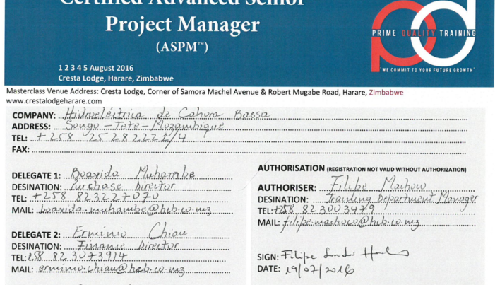**Definition:** Valid registration form contains following

* Authorized with full name of authoriser, clear job title, and clear signature.
* Clear name of delegate (or at least clear number of delegation with instruction “**Name to be confirmed later**”).
* Clear company name

*Sample as left*

1. **Identify if client is aware about course fee obligation**

* Call back to registration sender and identify if they are fully aware about pricing in USD per delegate.
* Identify mode of payment (We only accept Bank Transfer/Telegraphic Transfer/Swift Transfer. Cash on site may be explored as under approval of Finance in-charge)

Identify

* Identify estimated period of payment (How long does it take to process the invoice).
* We only accept currency stated in registration form, for other currency consult Finance Department.

1. **Issue Email Confirmation**

|  |
| --- |
| **Subject** : [Confirmation Email][Event Code][Event Name][Date][Location] |
| **CC** : [Person who send registration form][Sales Manager][Finance Manager][Operation Staff][Quality Control][All recipients sender CC when sending registration form] |
| **Content**:  Dear Mr. Sender,    Good day to you.  Thank you for your registration in our training event in **[Event Location]**.  This email is to confirm attendance of following **[number of delegates]** delegate:     1. **[Fullname 1 ] [Designation]** 2. **[Fullname 2 ] [Designation]**    of  **[Company Name]** to our [**Number of training days**] days International Event:  **​" [Event Name]** " *to be held between* **[Event Date]** at  *at* ​ **[Hotel Venue][Event Location]​**    Kindly reconfirm for spelling of participants' names and do let me know if there is anything else you would require for payment procedures and you are more than welcome to email me should you have other queries.    Our Finance department will send you another email with the invoice accordingly.    Please note that any cancellation will incur a cancellation penalty as stated in the signed registration form. We do allow a change of delegate(s) (replacement) but will require a written notification.    Moving forward, **[Operation Staff]**(being CC in this email)will be your Operation's point of contact and will be glad to assist should you require further information.    Thank you and warmest welcome.  Signature |

1. **Issue Booking Form**

**Definition** : Booking Form is an email instruction, instructing Finance Department to prepare invoice for clients and email to client

**Requirement:** Must attached valid registration form along Booking Form email sent to Finance

Send to Finance Manager

|  |
| --- |
| **Subject** : [Booking Form][Event Code][Event Name][Date][Location] |
| **CC** : [Sales Manager][Finance Manager][Sales Supervisor] |
| **Content**:  Address to: Mr/ Ms/Mrs. [Authoriser of Registration Form]  [Company Full Name]  [Company Physical Address]  **Masterclass**: [Masterclass Name] [ Masterclass Code]  Number of delegate: []  Attendees:   1. **[Fullname 1 ] [Designation]** 2. **[Fullname 2 ] [Designation]**​   Registration Fee: USD  [......] / delegate. *If discounted, specify discount approver*  Booking Creator: *Whom creates this booking form*  Sales Creator: *Whom this sales belongs to*  Sales Closing Name: *Whom close this sales (This is usually for part time sales whose deals are closed by their full time supervisor, hence Sales Creator is part time sales if NCL entries are valid, Sales Closing Name is his/her full time sales supervisor)*  Client contact of Procurement Department *Need official email address*  Client contact of Finance Department *Need official email address*  Client contact of Training Department *Need official email address*  Email to: [Whom send the registration form]  ​CC: [Whom authorize the registration form] [Whomever being CC in the email from clients company] [Sales Manager]  Signature |

Finance Manager / VN Office: [Jimmy@pri-qua.com](mailto:Jimmy@pri-qua.com)

Quality Control / [ncl@pri-qua.com](mailto:ncl@pri-qua.com)

1. **Update Booking Form Sheet inside Excel NCL**

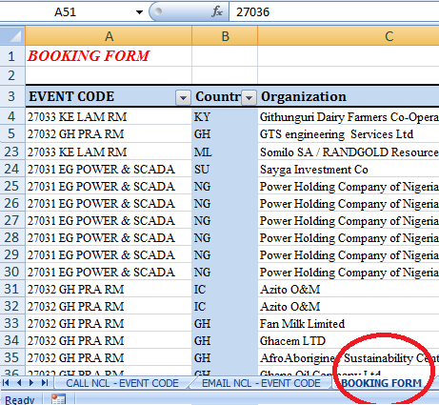

**3. My client has registered, and received invoice but 3 working days already passed, I haven’t heard about solid payment proof from Finance.**

When your clients are not clear about payment after registration, after 03 working days, it is a sign of some percentage of cancellation. Quickly prepare LOU (Letter of Undertaking) and send to the delegate, ask them to sign the paper and resend to you immediately.

You can look for LOU at directory PQ Server\Sales\[SALES] FORMS & TEMPLATES

**4. My client has registered, but registration is less than 03 weeks prior to event date.**

When your clients registration is less than 03 weeks prior to event date. Quickly prepare LOU (Letter of Undertaking) and send to the delegate, ask them to sign the paper and resend to you immediately.

You can look for LOU at directory PQ Server\Sales\[SALES] FORMS & TEMPLATES